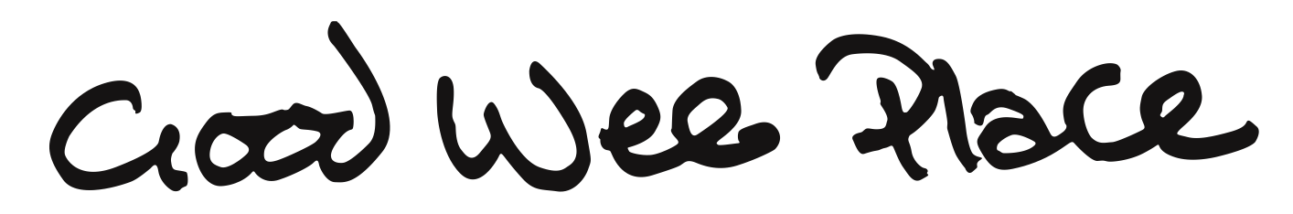

Hi there,
We're writing with an invitation to help us make a difference for many people in our city.
You may have seen media coverage of the UK Supreme Court judgment on the Equality Act, and the subsequent transphobic guidance issued by the EHRC. These unclear and mixed messages have created an environment of fear leaving many trans and gender non-conforming people feeling unwelcome and unsafe in many public spaces.
We believe that a culture of segregation makes life worse for everyone and we’re hoping you can help us do something about it.
Good Wee Place is a simple, community-led project. We’ve created a website and some stickers to invite venues to show that trans and queer people are welcome and can use your facilities without being questioned or made to feel unsafe.
We’re asking venues displaying the sticker to agree to:
- Respect everyone's identity: Use the names and pronouns people ask you to use, without question or debate.
- Challenge discrimination: Speak up when you witness transphobia or gender-based discrimination in your space.
- Provide safe facilities: Allow people to use the bathroom that aligns with their gender.
- Educate your team: Train staff to be respectful and supportive of trans and genderqueer customers and colleagues.
- Listen and learn: Be open to feedback and willing to improve your practices to better serve the community.
That’s it. simply a commitment to kindness, inclusion, and common sense.
So please display your Good Wee Place sticker prominently and share your venue on GoodWeePlace.com to let people know where to go. It’s a small thing but it’ll make our city more welcoming for everyone.
Thank you so much for supporting our important venture.
Kindest,
JJ,
P.S. Please tell your friends – anyone can request a free sticker for their venue on the site, so please go ahead and help us get the word out there. Thanks again!

